PLEASE USE BLOCK LETTERING |  | Student Name:
 |  | School (Full Name & Address)
 |  | Year Level  (Circle Appropriate) | Prep / Kindergarten | Yrs 1 & 2 | Yrs 3 & 4 | Yrs 5 & 6
Contact Person (Consenting Legal Guardian)
I have read, and accept, the conditions of entry
(please tick the box, write your name and sign)
Print Name:
Signature:
 |  | Phone:
Please ensure all parts of the entry form are completed IN FULL.
If entry forms are not complete, we regret we cannot submit the entry for judging.
Attach entry form to the BACK of entry using glue or sticky tape (please DO NOT use staples, pins or paperclips)
Entries must reach Dylan.magrin@centralcoast.nsw.gov.au by 22nd September 2023
CONDITIONS OF ENTRY Entries must be of A3 size. By submitting the entry form, entrants will assign a limited copyright of the image to the competition organisers enabling reproduction of the image for public displays and publications (both printed and digital) in conjunction with the competition AND for the purpose of publication in printed and digital material promoting water conservation, including National Water Week in subsequent years. Artists will be credited whenever the posters are used. Entries from students under the age of 18 must have adult consent. Signing of the entry form for this competition constitutes acceptance of these conditions of entry.
* For further information please contact Dylan.magrin@centralcoast.nsw.gov.au

National Water Week Poster Competition in Australia
Proudly supported by: | Proudly brought to you by:
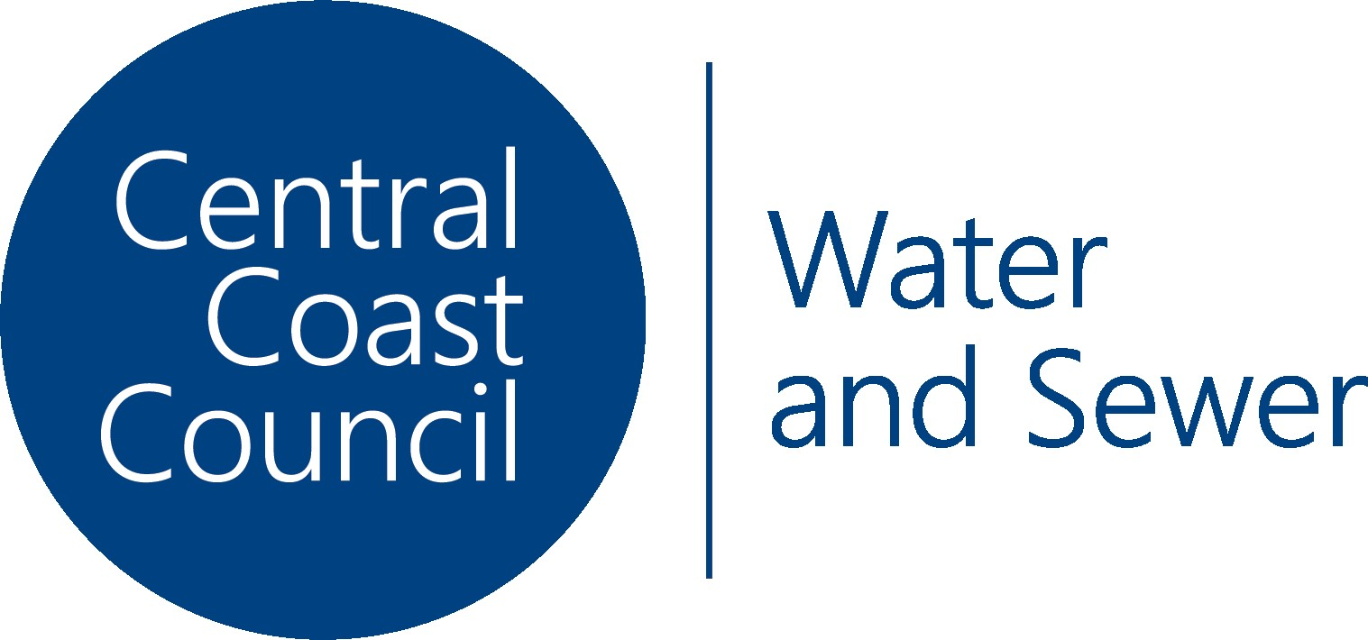 | 
The Australian water sector is committed to protecting information provided in accordance with the principles of the Information Privacy Act 2000. Information contained in your entry form/s may be stored and used by the water corporation administering your completion for the purpose of managing National Water Week events. Failure to provide contact details for entry into the NWW Competitions will constitute an invalid entry. This information may be disclosed to relevant government agencies or other stakeholders for these purposes.

